

University of the Punjab

Gujranwala Campus

Final Project Proposal
Version 1.0

Table of Contents

1. Introduction 3
1.1 Project Title 3
1.2 Project Overview Statement 3
1.3 Project Overview Statement Template 3
1.4 Project Goals & Objectives 4
1.5 High-level system components 4
1.6 List of optional functional units 4
1.7 Exclusions 5
1.8 Application Architecture 5
1.9 Gantt chart 6
1.10 Hardware and Software Specification 6
1.11 Tools and technologies used with reasoning 6

1. Introduction

1.1 Project Title
JASEPER SEO

1.2 Project Overview Statement
The objective of this project is to develop a web-based Blog Ranking SEO Tool using artificial intelligence. This tool aims to streamline the process of optimizing blog content for search engine visibility and effectiveness. Users will input specific keywords, and the tool will utilize web scraping techniques to retrieve relevant data from the internet. The retrieved data will then be processed and analyzed using AI algorithms to provide comprehensive ranking results. This tool is designed to assist content creators and digital marketers in making data-driven decisions to enhance their blog's search engine performance.

1.3 Project Overview Statement Template
Project Title: JASPER SEO
Group Leader: Talha Younas
Project Members:
Name | Registration # | Email Address | Signature
Azeem Ali | BIT20214 | azeemali0346634@gmail.com
Daoud Ur Rehman | BIT20231 | daoudurrehman1@gmail.com
Talha Younas | BIT20253 | talhamughal52352@gmail.com

Project Goal: Develop a SEO tool that analyzes blog content based on user-input keywords, leveraging AI for comprehensive insights.
Objectives:
Sr.#
1 | System will allow users to login/sign up for creating optimized content.
2 | System will allow admin to manage the users.
3 | System will allow admin to send reports or invoices to the users for our paid services.
4 | System will allow users to purchase our packages for getting advanced features.
5 | System will allow users to purchase our packages by different payment methods, including credit cards, and bank transfers.
6 | Interactive Mapping
7 | Data Accuracy and Quality

Project Success criteria: Achieve a high level of precision in SEO recommendations, ensuring relevance to user-input keywords. Retrieve data from internet with optimal speed for efficient results. Adhere to industry-standard security practices and complete the project milestones on schedule.
Assumptions, Risks and Obstacles:
- Integration copyrights.
- Our system may get slow in case of heavy traffic.
Organization Address (if any): None
Type of project: Research Development
Target End users:
- Digital Marketers and SEO Professionals
- Content Creators and Bloggers
- Marketing Students and Enthusiasts
- Freelance Writers
Development Technology: Object Oriented Structured
Platform: Web based Distributed
Desktop based Setup Configurations
Other_____________________
Suggested Project Supervisor: Dr. Ghulam Mustafa
Approved By:
Date: October 10, 2023

1.4 Project Goals & Objectives

Goal
The project aims to create a Web-Based Blog Ranking SEO Tool, utilizing AI for targeted keyword-driven analysis. It will efficiently retrieve data from internet, process insights, and offer customizable reports. The user-friendly tool will prioritize security, scalability, and user support, ensuring a valuable resource for optimizing blog content.

Objectives
- System will allow users to login/sign up for creating optimized content.
- System will allow admin to manage the users.
- System will allow admin to send reports or invoices to the users for our paid services.
- System will allow users to purchase our packages for getting advanced features.
- System will allow users to purchase our packages by different payment methods, including credit cards, and bank transfers.
- Interactive Mapping
- Data Accuracy and Quality

1.5 High-level system components
Generally, an integrated application is composed of many different components that work collectively to address the problem for which the system has been devised. The high-level system components for our application are.
- Authentication module
- Keyword Searching module
- User module
- Admin module
- Payment Gateway module
- Notifications module.
- Content/Blog editor module.

1.6 List of optional functional units
- Integration with social media.
- Feedback module.
- Chatbot module

1.7 Exclusions
- Development of mobile applications.
- Implementation of paid advertising campaigns.
- Hosting and server maintenance responsibilities.
- Integration with external third-party tools or platforms not specified in the project scope.
- Content creation or writing services for blogs.
- SEO strategy consultation beyond the scope of the tool's functionalities.
- Training or tutorials for general SEO practices unrelated to the tool's specific features.

1.8 Application Architecture
We will follow 3-tier Architecture.

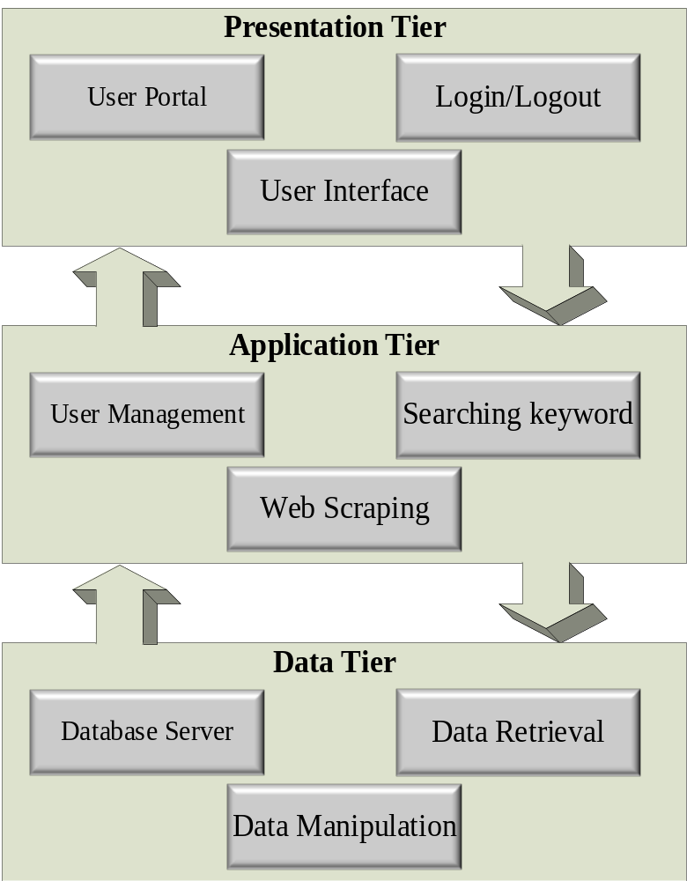

1.9 Gantt chart

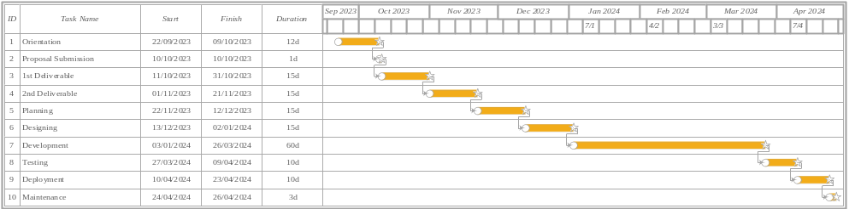

1.10 Hardware and Software Specification
Hardware: (Recommended)
- 2.2 GHz Quad-core Processor
- Qualcomm Snapdragon 630
- 3 GB Ram
- 2 GB Storage
Software: (Recommended)
- Android 9+
- IOS 12+
Browser: (Recommended)
- Chrome
- Firefox
- Brave

1.11 Tools and technologies used with reasoning
Tools:

- WebStorm
WebStorm developed by JetBrains is a powerful IDE tailored for web development. It offers advanced JavaScript support, intelligent code completion and seamless integration with version control systems like Git. With features for debugging, syntax highlighting and code refactoring. It provides a comprehensive toolkit for efficient coding on Windows, Linux, and macOS platforms.

- PyCharm
PyCharm is an integrated development environment (IDE) created by JetBrains specifically designed for Python development. It offers a wide range of features including intelligent code completion, syntax highlighting, debugging support, version control integration and code refactoring. With its user-friendly interface and powerful tools, PyCharm streamlines the development process that making it a popular choice for Python programmers on Windows, Linux, and macOS platforms.

- GIT and GitHub
Git is a widely used version control system that allows developers to track changes in their codebase. It provides features like branching, merging, and history tracking, enabling collaborative development and efficient management of code.

GitHub is a web-based platform that utilizes Git for version control. It serves as a hosting service for Git repositories, allowing developers to store and manage their code online. GitHub provides additional features such as issue tracking, pull requests, and project management tools, making it a popular platform for open-source collaboration and software development projects.

- Figma
Figma is a cloud-based design and prototyping tool used for creating user interfaces and interactive design prototypes. It offers a collaborative platform where multiple team members can work simultaneously on design projects that enables real-time feedback and seamless coordination. With features like vector editing, prototyping and design libraries, Figma streamlines the design process and facilitates efficient communication between designers and stakeholders. Its cloud-based nature allows for easy access and sharing of design files across different devices and platforms that making it a versatile tool for UI/UX designers.

- phpMyAdmin
phpMyAdmin is a web-based interface for managing MySQL databases. It provides a user-friendly platform for performing various database operations including creating, modifying and deleting databases and tables. With features like SQL query execution, data import/export and user management. phpMyAdmin simplifies the process of database administration. It is a valuable tool for developers and database administrators that offering a graphical interface to interact with MySQL databases and perform tasks efficiently.

- Microsoft Visio
Microsoft Visio is a versatile diagramming tool by Microsoft used for creating flowcharts, organizational charts and various visual representations. With a user-friendly interface and pre-defined templates. It simplifies the process of visualizing complex information for professionals across different industries.

- Colab
Google Colab is a cloud-based Python development environment by Google. It offers free access to powerful computing resources that making it ideal for tasks like machine learning and data analysis. With its collaborative Jupyter notebook interface, it's a convenient choice for coding projects without the need for extensive local resources.

Technology:
- Next.js
Next.js is a powerful React framework that facilitates the building of server-rendered React applications with ease. It offers features like static site generation and server-side rendering, allowing for efficient SEO optimization and enhanced performance. With its intuitive file-based routing system and support for JavaScript. Next.js provides a robust foundation for developing modern high-performance web applications. It is a popular choice among developers for its seamless integration with React and efficient rendering capabilities that making it well-suited for projects requiring dynamic, SEO-friendly web pages.

- Express.js
Express.js is a powerful and flexible web application framework for Node.js. It provides a robust set of features for building web applications. With its minimalist and flexible design, Express.js simplifies the process of creating APIs and handling routes. It also supports various middleware that making it easy to integrate additional functionality. Express.js is a popular choice for backend development due to its scalability and ease of use which making it well-suited for projects requiring efficient and customizable server-side solutions.

- MySQL
MySQL is a widely-used open-source relational database management system. It provides a reliable and efficient platform for storing and retrieving data. With its robust features including support for transactions, indexing and querying. MySQL is well-suited for managing structured data in web applications. It offers scalability and high performance that making it a popular choice for a wide range of projects. MySQL is known for its stability, security and ease of integration with various programming languages and frameworks which makes it a versatile and trusted database solution for many developers.

- Python (Sentence-Transformers Model)
Sentence-Transformers Model is a state-of-the-art natural language processing (NLP) tool that specializes in transforming sentences and text paragraphs into numerical representations. It employs advanced techniques like Siamese and triplet network architectures along with transfer learning from large-scale datasets. This enables it to generate highly meaningful and contextually rich embeddings for text. In our project, the Sentence-Transformers model plays a crucial role in tasks like semantic similarity assessment, text clustering and information retrieval. Its capabilities make it an invaluable tool for advanced NLP applications that enhancing the project's ability to extract and process information from text data efficiently and accurately.

